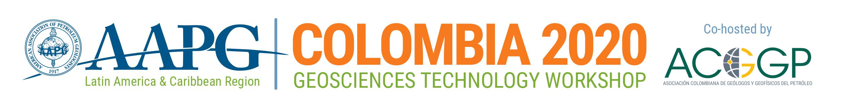
Exploration and Development in Southern Caribbean Frontier Basins
1-3 April 2020 l Barranquilla
Presentation Proposal Form
To complete the form, click in the first field (beside Company Name), then tab through or click in subsequent fields to complete all sections. When finished, save the document, and send it via email to lacevents@aapg.org.

SUBMISSION DEADLINE: 31 January 2020

Company Name:

Presentation Name:

Presentation Author(s):

Presenter Name:

Presenter Email:

Session (Select One):

Tectonic Setting and Petroleum Systems

Recent Discoveries and New Plays

Enhancing Imaging and AVO/DHI

Risk Reduction and Drilling Optimization

Poster Session – Tools & Technology to Optimize Exploration & Production

Presentation summary:
(Please include a few sentences about the proposed topic and its relevance to the workshop. Summaries of selected presentations will be published in the event program.)

Summaries and presentations must be submitted in English. Only English language materials will be published on the AAPG Search & Discovery website following the workshop.
If selected for the program, presenters will be asked to submit English language presentations in Power Point or PDF format.

