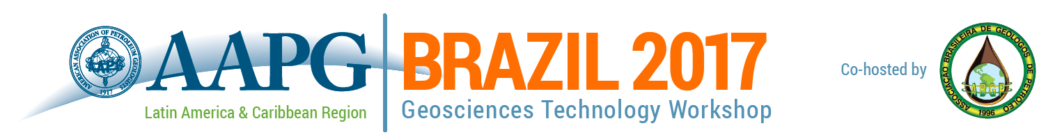
Optimization of E&P Projects: Integrating Geosciences and Engineering from Block Acquisition through Production
Hotel Rio Othon Palace l Rio de Janeiro l 22-23 August 2017
Presentation Proposal Form
To complete the form, click in the first field (beside Company Name), then tab through or click in subsequent fields to complete all sections. When finished, save the document, and send it via email to latinamerica@aapg.org.

SUMISSION DEADLINE: 28 April 2017

Company Name:
Presentation Name:
Presentation Author(s):
Presenter Name:
Presenter Email:
Session (Select One):

Including Production Information in Exploration Phases & Geological Models
Incorporating New or Revised Seismic Technology
Implementing Advanced Well Technologies
Improving Projects through Data Management

Presentation summary:
(Please include a few sentences about the proposed topic and its relevance to the workshop. Summaries of selected presentations will be published in the event program.)

Summaries and presentations must be submitted in English. Only English language materials will be published on the AAPG Search & Discovery website following the workshop. If selected for the program, presenters will be asked to submit English language presentations in Power Point or PDF format.

