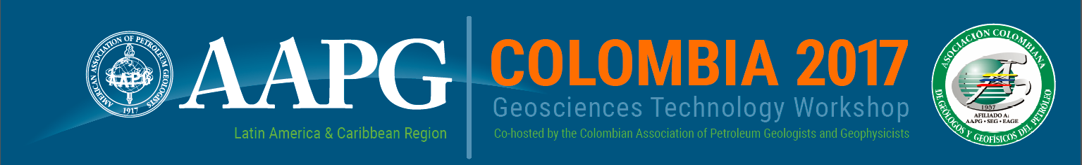

Optimizing Geoscience and Engineering to Explore and Produce in a Low Price Environment
Bogotá, Colombia l 17-18 May 2017 l NH Collection Teleport

The AAPG Latin America & Caribbean Region and the Colombian Association of Petroleum Geologists and Geophysicists (ACGGP) invite your company to be a part of GTW Colombia 2017, a specialized workshop bringing leading scientists and industry practitioners to share best practices, exchange ideas and explore opportunities for future collaboration.

Sponsorship provides your company with high visibility among the industry, government, and academic specialists attending the event, as well as to a global audience on the Internet. All monies contributed will be used to offset conference expenses and to provide support to students, young professionals and speakers who need financial assistance in order to attend the workshop.

SPONSORSHIP LEVELS

Diamond: | $15,000 USD |  |  | Silver: | $ 5,000 USD
Platinum: | $10,000 USD | ECOPETROL  ANH |  | Bronze: | $ 3,000 USD SHELL  BAKER HUGHES
Gold: | $ 7,500 USD |  |  | Patron: | $ 1,000 USD

SPONSOR RECOGNITION
All sponsoring companies will receive the following:
- Company logo and link to corporate webpage displayed on event website
- Verbal recognition of company’s contribution at the opening and closing of the GTW
- Sponsor logo included on “Thank You Sponsors” slide displayed during the opening session and during all breaks
- Company logo included on program folder
- Company logo on welcome banner displayed throughout workshop
- One complimentary workshop registration ($695 value) for every $5000 USD spent in sponsorship

Secure your sponsorship by completing & returning the commitment form on the following page

Questions?
Contact Emily Smith Llinás, Programs Manager, AAPG Latin America & Caribbean Region
Tel: +571.551.1182| Cel: +57.310.305.7937 | USA: +1.281.886.8525| Email: ellinas@aapg.org

Optimizing Geoscience and Engineering to Explore & Produce
in a Low Price Environment
Bogotá, Colombia l 17-18 May 2017

SPONSORSHOP COMMITMENT FORM

Company |  | Item |  | Amount
Contact |  | Email |  | Phone

PAYMENT METHODS ACCEPTED:
- Checks (United States or Canadian banks only): send to AAPG ACCOUNTING P. O. BOX 979, TULSA, OK 74101-0979
- Credit Card: Complete information below, sign and return form
- Direct Bank Transfer: Commerce Bank, 1000 Walnut St, Kansas City, MO 64106 USA
Account # 000026752 ABA Routing #101000019 Swift # CBKCUS44

ALL PAYMENTS MUST BE MADE IN U.S. DOLLARS

TO PAY BY WIRE TRANSFER, COMPLETE THE FOLLOWING:

Contact Name |  | Phone
Company |  | Email
City |  | State
Postal Code |  | Country
Amount(USD) |  | Transfer date
Bank Name |  | Bank City
Bank Country

TO PAY BY CREDIT CARD, COMPLETE THE FOLLOWING:

Contact Name |  | Phone
Company |  | Email
Address
City |  | State
Postal Code |  | Country

Select one: |  | Visa |  | MasterCard
 |  | Discover |  | American Express

Card Number
Expiration Date |  | CVV#
Name on Card
Amount (USD) | $ | Date:
Signature

Please return this form along with supporting document(s) and send to AAPG ACCOUNTING P. O. BOX 979, TULSA, OK 74101-0979 or to latinamerica@aapg.org. This information will help us track and credit your payment appropriately.

