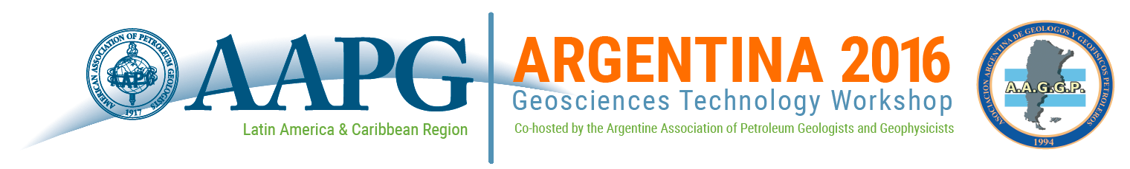
Moving toward the Prediction of Unconventional Plays: Lessons Learned from Tight and Shale Reservoirs in the Neuquén Basin
Buenos Aires, Argentina l 16 – 18 November 2016
Presentation Proposal Form
To complete the form, click in the first field (beside Company Name), then tab through or click in subsequent fields to complete all sections. When finished, save the document, and send it via email to latinamerica@aapg.org.

SUMISSION DEADLINE: 28 OCTOBER 2016

Company Name:
Presentation Name:
Presentation Author(s):
Presenter Name:
Presenter Email:

Session (Select One):

Tight Gas Case Studies
Tight Gas Applied Technologies
Shale Reservoir Case Studies
Shale Reservoir Applied Technologies

Presentation summary:

(Please include a few sentences about the proposed topic and its relevance to the workshop. Summaries of selected presentations will be published in the event program.)

Summaries and presentations must be submitted in English. Only English language materials will be published on the AAPG Search & Discovery website following the workshop.
If selected for the program, presenters will be asked to submit English language presentations in Power Point or PDF format.

