An Efficient, Consistent, and Trackable Method to Quantify Organic Matter Hosted Porosity from Ion-milled SEM Images of Mudrock
Liaosha Song¹, Travis Warner², Timothy Carr¹
1. Department of Geology and Geography, West Virginia University, Morgantown, WV, 26506
2. EQT Corporation, Pittsburgh, PA, 15222

Supplementary material
Step-by-step ImageJ/Fiji procedure
Download ImageJ/Fiji, and install it.
Open Fiji, the interface looks like this:
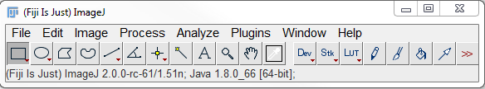
To open an image: File > Open, then choose the SEM image in local drive.
To switch the input image to an 8-bit image: Image > Type > 8 bit.
To use median filter to reduce the noise: Process > Filters > Median, set the radius to 2 pixels, then OK.
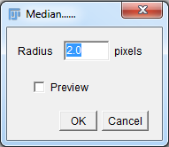
Duplicate the converted image, one for segmenting the pores, the other for segmenting the organic matter: Image > Duplicate. Then save them, File > Save As > Tiff. Name one as porosity, the other as organic matter and pores.
- Segmentation of the pores.
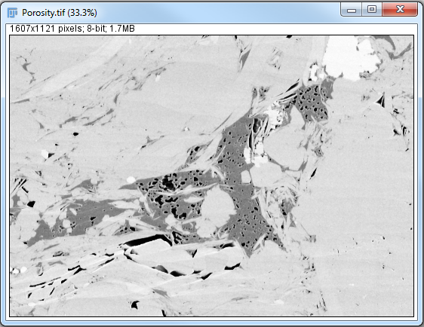
To Segment the pore space using adaptive local thresholding: Image > Adjust > Auto Local Threshold.
In the following window, select Phansalkar in Method, the default Radius is 15 pixels. Set both Parameter 1 and 2 to be 0.5, keep White objects on black background checked, then OK.
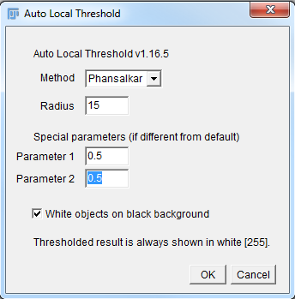
The segmented pore space is list as following shown in black.
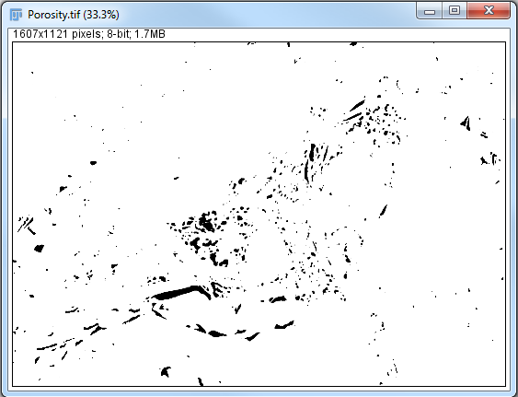
Invert foreground and background, Process > Binary > Make Binary.
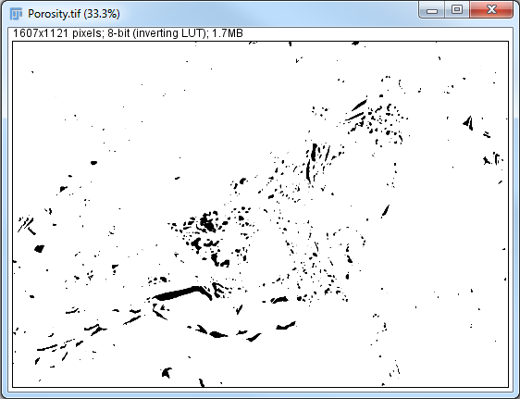
To analyze the area, geometry features etc.: Analyze > Analyze Particles
- Segmentation of the organic matter
To segment the organic matter, first click on the image Organic matter and pores.
Then Image > Adjust > Threshold. Choose Otsu thresholding, then Apply.
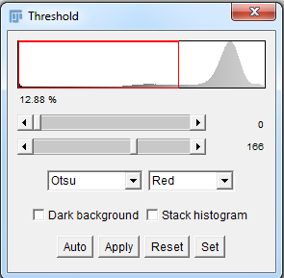
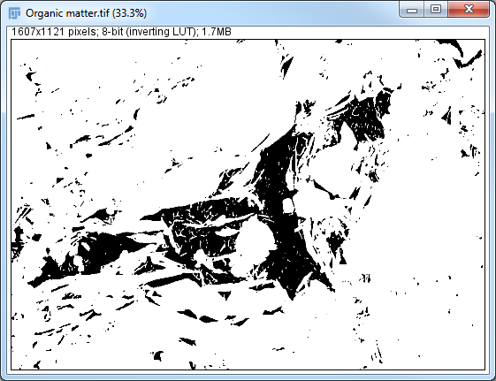
To use Image Calculator: Process > Image Calculator, and set the window like following.
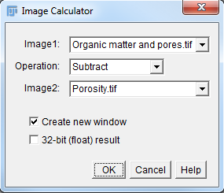
Apply Process > Filters > Median set radius to be 1 pixel to remove the pore border if necessary. The result is listed as following. Save it as Organic matter.
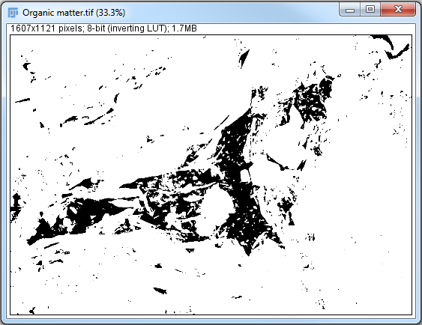
Area and geometry features can be acquired by Analyze > Analyze Particles.
- Differentiating organic matter hosted pores and mineral hosted pores
Apply Process > Binary > Dilate to segmented OM. By running this process one time, the organic matter will be dilated by 1 pixel. Repeat this until the unenclosed pores on the border of organic matter become enclosed. For this particular case, dilation of the organic matter by 3 pixels was chosen. Then apply Process > Binary > Erode to remove the same amount of dilated pixels. The result is listed as following.
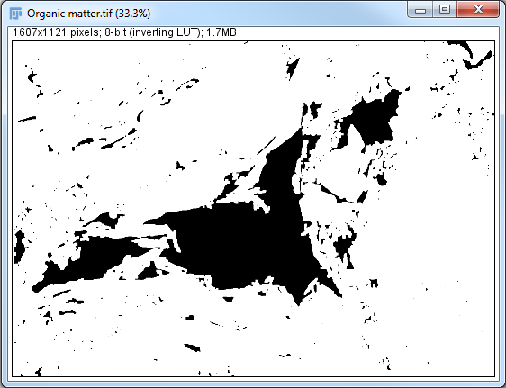
Apply Image Calculator again. Set the window as following. Save the result as mineral hosted porosity.
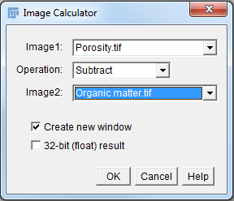
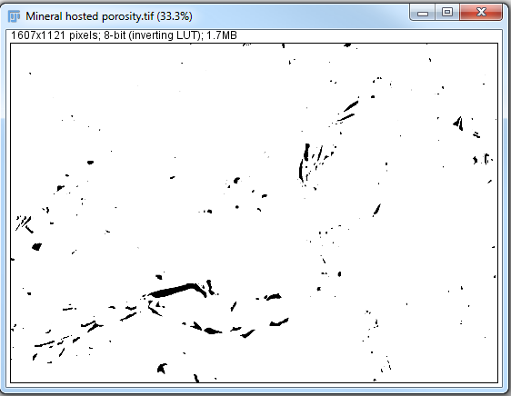
Run Image Calculator again. Set the window as following. Then save the result as organic matter hosted porosity.
