Report for 2018 AAPG YP India Chapter

Summary:
It gives me immense pleasure to share with you that AAPG Young Professional (YP) chapter of India has been rejuvenated. Since my induction as AAPG YP coordinator for India-Pakistan-Bangladesh on February 2018, two events have been planned successfully. My teammate Ms. Reetu helped me in coordinating with the AAPG YP SIG members. There were two Professional Talks by a senior AAPG member Mr. K. Vasudevan, General Manager (Geology), ONGC Ltd, as requested by respective AAPG student chapters in the Universities. Sankhadip gave an introductory briefing on the overview of the functions of AAPG YP to the students and faculties in each of the events. All the participants were very happy to attend the event as they got new insights required to be successful in their near future professional career. Students expressed their interests for possible upcoming events of this kind. A brief report is prepared for your reference.

First Event: 7th April 2018 at Indian Institute of Technology Roorkee (IITR), India on “Competencies and Skill sets of Future Petroleum Geoscientists”:
On 7th April 2018, AAPG YP India has organized its first event at Indian Institute of Technology (IITR), Roorkee, India. AAPG Student chapter of IITR has requested AAPG YP India to arrange a professional talk on “Competencies and Skill sets of Future Petroleum Geoscientists”. It was a fairly good turnout of around 100 students of UG & PG students of Geology and Geophysics discipline, Research Scholars and faculties of IITR. Faculty advisor Dr. Ravi Sharma grace the occasion and appreciated the efforts of AAPG YP India to arrange such an event at IITR for the first time, where students get the opportunity to know about the skill sets required in Petroleum Industry. Such events provide a good networking opportunity and help to bridge the gap between Industry and Academia. A good mixture of seniors and juniors who have joined also yield a good discussion after the one and half hour talk. The event begins at 9 am sharp and continued up to 12 pm. After that, high tea was arranged by AAPG YP representative for the attendees and a memento was given to the speaker Mr. K. Vasudevan, a senior AAPG member on behalf of AAPG YP India representative, followed by a group picture (See Annexure for Pictures no 1-5).

Second Event: 19th to 20th April 2018 at University of Petroleum and Energy Studies (UPES), Dehradun, India on “Key Factors in Success in Upstream”:
AAPG Student Chapter of UPES, Dehradun is very active and it is very close to my working area. They sought AAPG YP’s help in organizing their AAPG fest “Excalibur 2018”. A two-day workshop was arranged on 19th -20th April 2018 in the Virtual Reality Centre (VRC) facility, available at ONGC Ltd. Dehradun under the umbrella of AAPG YP India, along with an interactive session with Mr. K. Vasudevan, GM (Geology) on ‘Key Factors of Success in Upstream’ was arranged on 20th April 2018 at UPES premises Dehradun. It was attended by around 75 students of different batches of Petroleum Engineering and faculties. Dr. Uday Bhan, Faculty advisor of UPES, Dehradun was present and congratulated AAPG YP India efforts for providing the students of UPES a unique opportunity to experience closely the industry standard practices of Seismic Data Processing, Interpretation, Data Storage facility etc. for upstream business. He said that “We are fortunate to have had someone of your professional expertise and credentials volunteer time from your busy schedule to address the participants and serve as a resourceful person.” The talk was scheduled for 2 pm and continued till 5 pm. After an extensive question and answer session, mementos were given to speaker and AAPG YP India representative by UPES AAPG Student chapter, followed by a group picture (See Annexure for Pictures no 6-10).

Future Plans of AAPG YP India:
UPES AAPG Annual Fest is scheduled in October 2018. They are seeking AAPG YP India’s help. It's still in the planning stage. We have a huge scope for growth of AAPG in India. I am planning some networking events and a field trip in the next year, exclusively for professionals. It would be great if AAPG YP India gets involved in the core planning committee of AAPG YP so that we can communicate with the core team and plan our events accordingly. I think there is a scope to grow internally as well, we need to know YP’s from other parts of the world. Help in clearing membership queries that I get very frequently is one of the important areas to work upon.

Annexure:
Picture 1: AAPG YP First Event Poster
Picture 2: Mr. K. Vasudevan Delivering the Lecture at IITR
Picture 3: Students at IITR attending the talk
Picture 4: Memento
Picture 5: Group Picture at IITR
Picture 6: Welcoming AAPG YP Representative and Speaker at UPES, Dehradun
Picture 7: Mr. K. Vasudevan Delivering the Lecture at UPES, Dehradun
Picture 8: Students attending the talk at UPES, Dehradun
Picture 9: Memento
Picture 10: Group Picture at UPES, Dehradun

The report is prepared by,
Sankhadip Bhattacharya
(Senior Geologist, ONGC Ltd.)
AAPG YP Coordinator of India-Pakistan-Bangladesh,
Cell: +91-9410390950
Mail: bhattacharya_sankhadip@ongc.co.in
Date: 30th June 2018

Annexure:
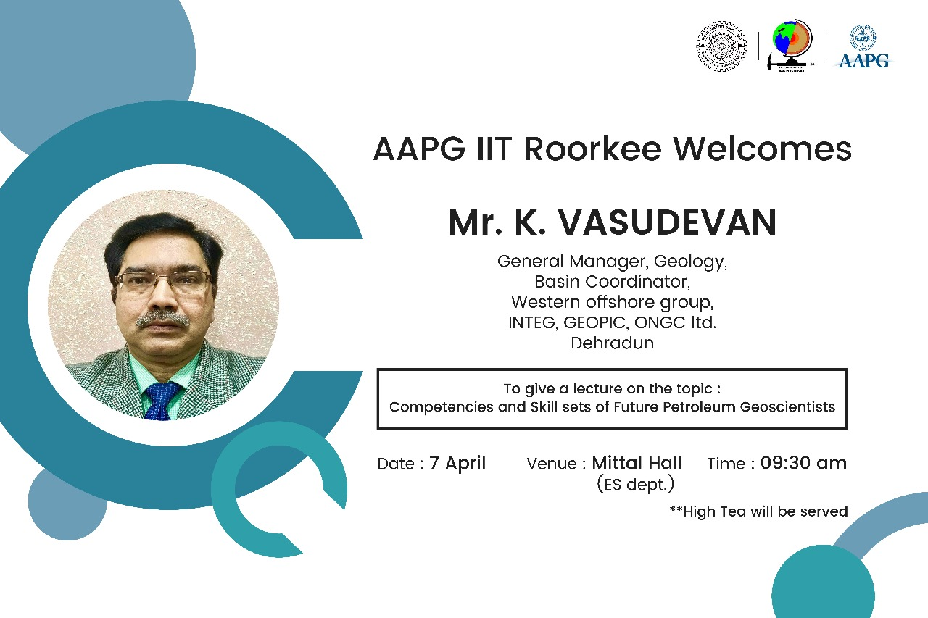
Picture 1: AAPG YP First Event Poster

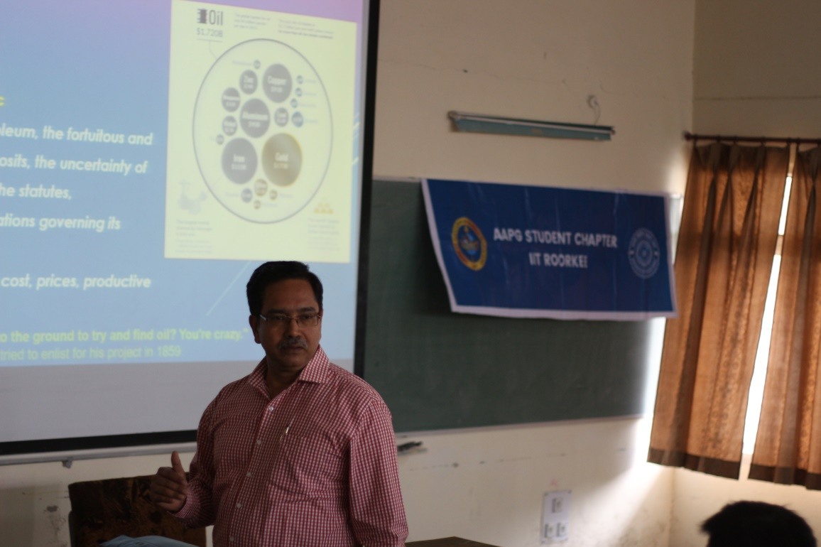
Picture 2: Mr. K. Vasudevan Delivering the Lecture at IITR

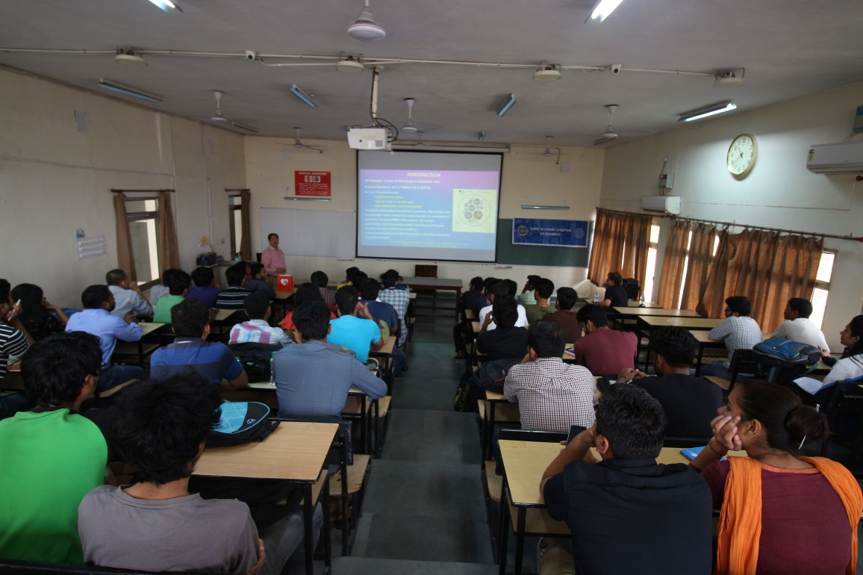
Picture 3: Students at IITR attending the talk

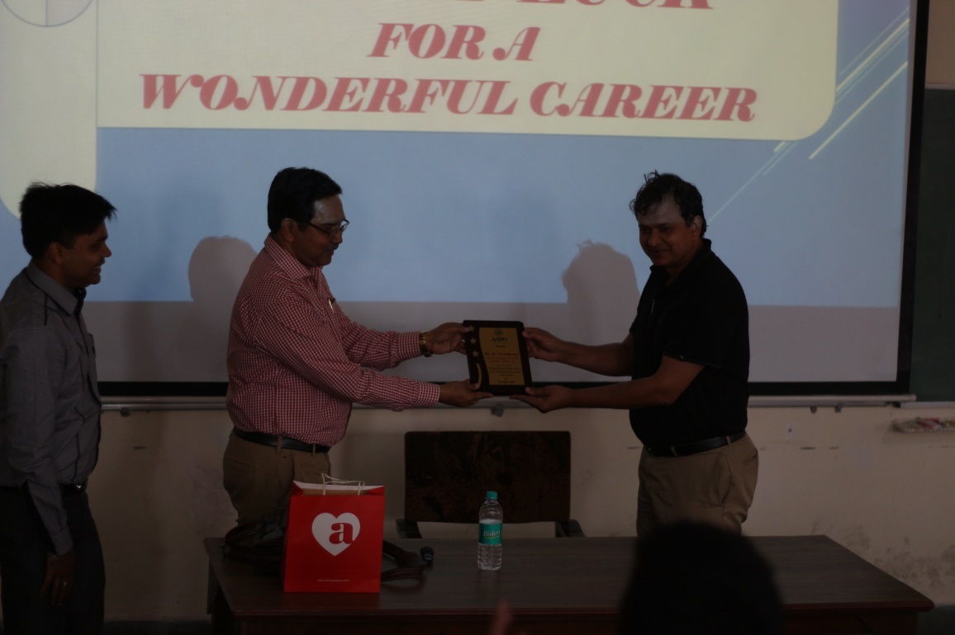
Picture 4: Memento

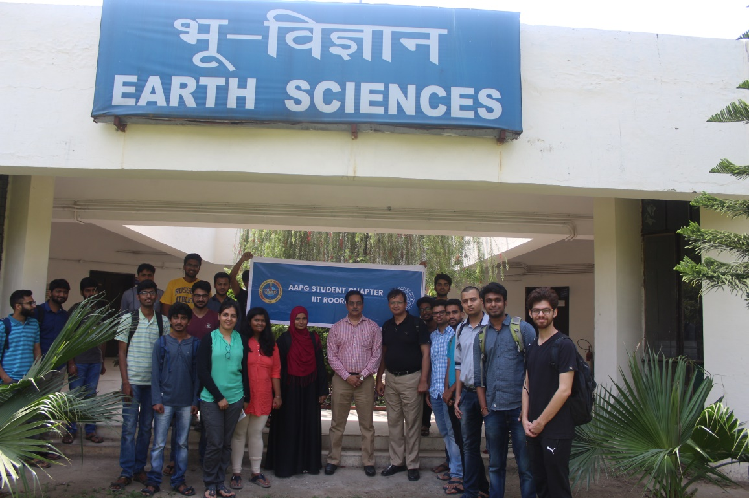
Picture 5: Group Picture at IITR

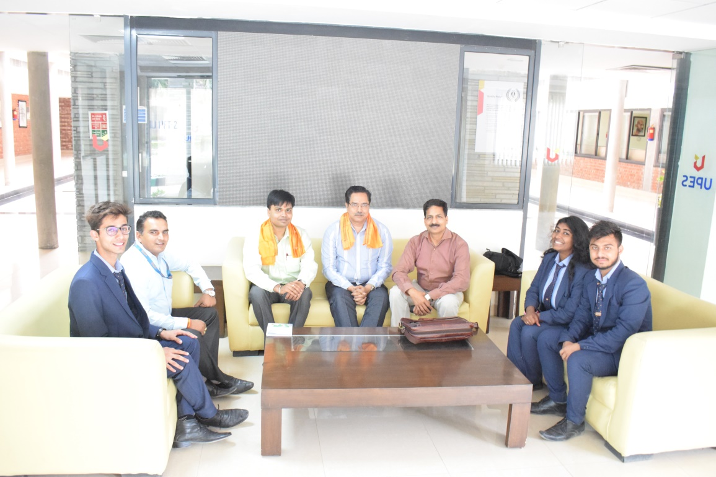
Picture 6: Welcoming AAPG YP Representative and Speaker at UPES, Dehradun

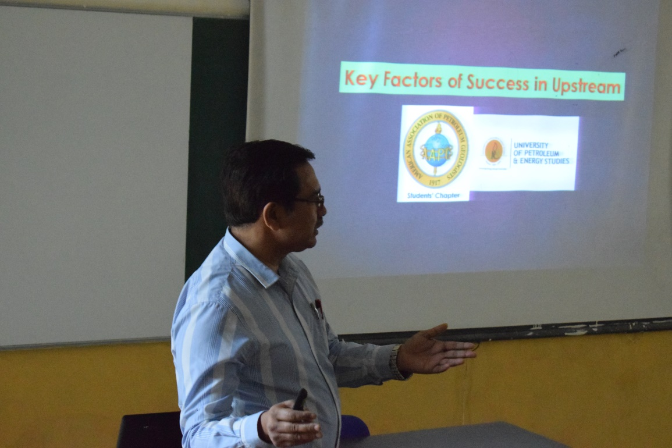
Picture 7: Mr. K. Vasudevan Delivering the Lecture at UPES, Dehradun

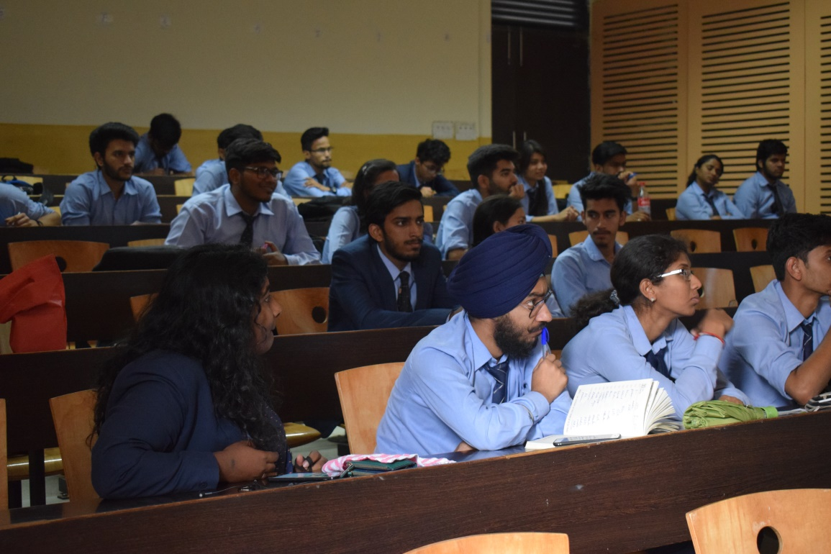
Picture 8: Students attending the talk at UPES, Dehradun

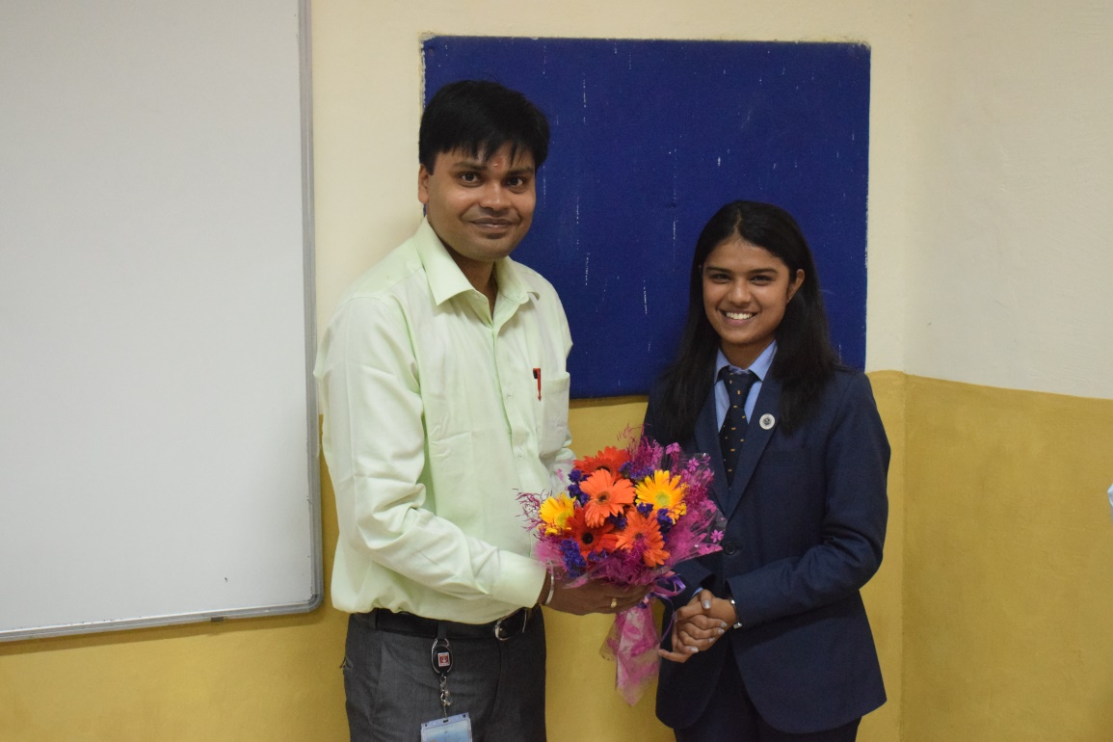
Picture 9: Memento

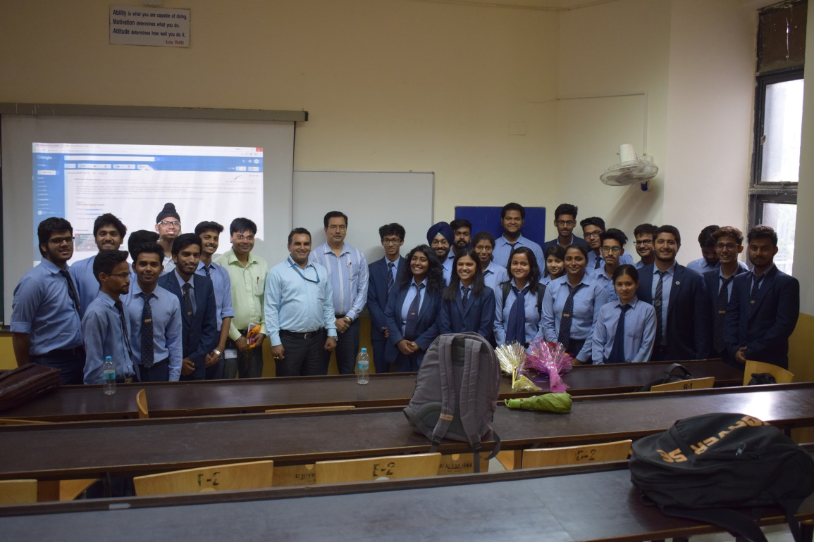
Picture 10: Group Picture at UPES, Dehradun

…………………………………….

