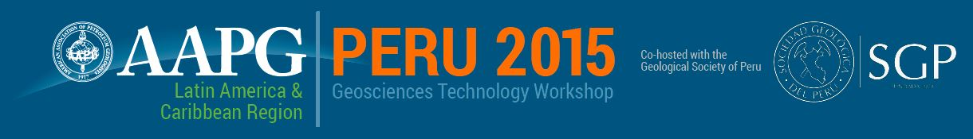
Abstract Submission Form
Increasing the Recovery Factor in Mature Oil & Gas Fields
15-16 October 2015

SUMISSION DEADLINE: 30 August 2015
To complete the form, click in the first field (beside Company Name), then tab through or click in subsequent fields to complete all sections. When finished, save the document, and send it via email to latinamerica@aapg.org.

Company Name:
Presentation Name:
Presentation Author(s):
Session (Select One):
Solution Gas Drive Fields
Water Drive and Heavy Oil Fields
Gas and Condensate Fields
New Technologies for Enhanced Oil Recovery
Presentation summary:

Abstracts may be submitted in English or Spanish. Only English abstracts will be published on the AAPG Search & Discovery website following the workshop.
If selected for the program, presenters will be asked to submit English language presentations in Power Point or PDF format. Presentations may be delivered in English or Spanish.

