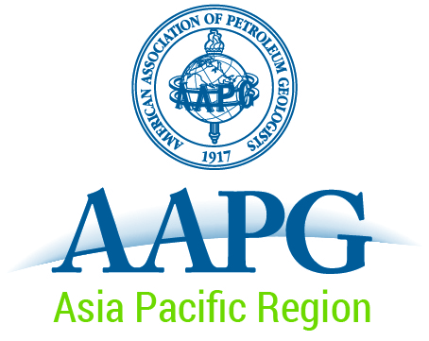
Geosciences Technology Workshop
“Modern Depositional Systems as Analogues for Petroleum Reservoirs”
REGISTRANT ACKNOWLEDGEMENT OF INDEMNITY
OPTIONAL ACTIVITIES
The Organisers of the Geoscience Technology Workshop have made arrangements for Registrants, at their option, to participate in either of the following activities on the day following the programme: Thursday, April 23, 2015:
- Core Workshop on New Zealand petroleum reservoirs including terrestrial, marginal marine and deep water cases.
- Field excursion to the modern depositional system of the Wairarapa Valley: range front to coast.
These two optional activities are being organised and run by members of the GTW organising committee. AAPG’s only involvement is in processing registration for GTW participants.
All participants in these activities will be briefed at the outset on Health and Safety considerations for each activity.
The Organisers and Leaders of each activity have resolved to make every effort to ensure that there are no incidents or accidents during the activities, but accept no liability to the Participants for any such incident.
As a Registrant for one of the Optional Activities to be undertaken on April 23, 2015, I hereby acknowledge that
- I have read the above,
- I will pay attention to the Health and Safety briefing at the outset of the activity,
- I will be cognisant of my own and others’ safety during the activity, and
- The Organisers are indemnified against any cost, claim, loss or liability arising from any incident associated with my participation in the activity.

Signature: _______________________________
Print Name: ______________________________
Date: ___________________________________

